Step 1 - Check the docker process

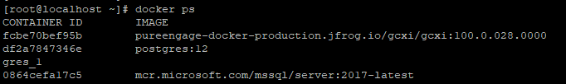

Step 2 - Login to GCXI container and run mstrcfgwiz-editor then press ENTER

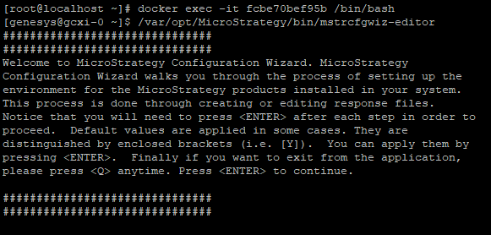

Step 3 – select 2 Create Response file -> select 5 to upgrade existing environment and choose 1

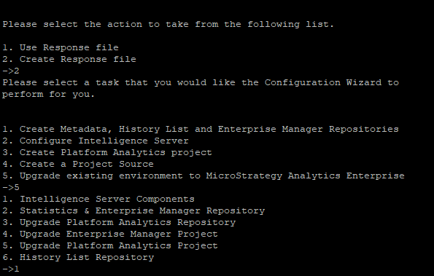

Step 4:- Then provide administrator credentials and select the project needs to be upgraded from the list.

It will create a response file and execute the same which will help you to update the custom projects.

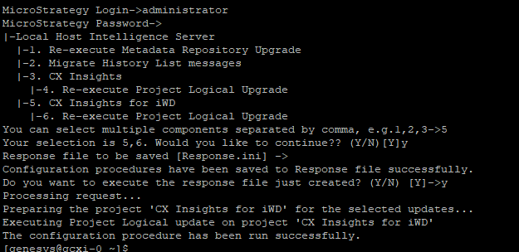

Raw steps

Step 1:-

[root@localhost ~]# docker ps

CONTAINER ID IMAGE COMMAND CREATED STATUS PORTS NAMES

fcbe70bef95b pureengage-docker-production.jfrog.io/gcxi/gcxi:100.0.028.0000 "/bin/bash -c 'sle..." 16 hours ago Up 16 hours 0.0.0.0:8080->8080/tcp, 0.0.0.0:8180->8180/tcp, 0.0.0.0:34952->34952/tcp ip_gcxi-0_1

df2a7847346e postgres:12 "docker-entrypoint..." 16 hours ago Up 16 hours 0.0.0.0:5432->5432/tcp ip_gcxi-postgres_1

0864cefa17c5 mcr.microsoft.com/mssql/server:2017-latest "/opt/mssql/bin/no..." 17 hours ago Up 17 hours 0.0.0.0:1433->1433/tcp sql-server-db

Step 2:-

[root@localhost ~]# docker exec -it fcbe70bef95b /bin/bash

[genesys@gcxi-0 ~]$ /var/opt/MicroStrategy/bin/mstrcfgwiz-editor

###############################

###############################

Welcome to MicroStrategy Configuration Wizard. MicroStrategy

Configuration Wizard walks you through the process of setting up the

environment for the MicroStrategy products installed in your system.

This process is done through creating or editing response files.

Notice that you will need to press <ENTER> after each step in order to

proceed. Default values are applied in some cases. They are

distinguished by enclosed brackets (i.e. [Y]). You can apply them by

pressing <ENTER>. Finally if you want to exit from the application,

please press <Q> anytime. Press <ENTER> to continue.

###############################

###############################

Step 3 :-

Please select the action to take from the following list.

1. Use Response file

2. Create Response file

->2

Please select a task that you would like the Configuration Wizard to

perform for you.

1. Create Metadata, History List and Enterprise Manager Repositories

2. Configure Intelligence Server

3. Create Platform Analytics project

4. Create a Project Source

5. Upgrade existing environment to MicroStrategy Analytics Enterprise

->5

1. Intelligence Server Components

2. Statistics & Enterprise Manager Repository

3. Upgrade Platform Analytics Repository

4. Upgrade Enterprise Manager Project

5. Upgrade Platform Analytics Project

6. History List Repository

->1

Step 4:-  
MicroStrategy Login->administrator

MicroStrategy Password->

|-Local Host Intelligence Server

|-1. Re-execute Metadata Repository Upgrade

|-2. Migrate History List messages

|-3. CX Insights

|-4. Re-execute Project Logical Upgrade

|-5. CX Insights for iWD

|-6. Re-execute Project Logical Upgrade

You can select multiple components separated by comma, e.g.1,2,3->5

Your selection is 5,6. Would you like to continue?? (Y/N)[Y]y

Response file to be saved [Response.ini] ->

Configuration procedures have been saved to Response file successfully.

Do you want to execute the response file just created? (Y/N) [Y]->y

Processing request...

Preparing the project 'CX Insights for iWD' for the selected updates...

Executing Project Logical update on project 'CX Insights for iWD'

The configuration procedure has been run successfully.

[genesys@gcxi-0 ~]$